**LIFE-CYCLE PHASES**

**Value TO THE BUS. OF SERVICE DESIGN:**

**Service strategy -> Service design -> Service design Package**

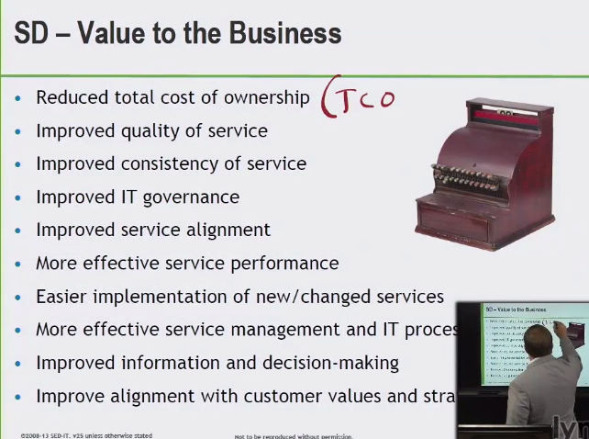

**TCO – Total Cost of Ownership**

**Quality of Service**

* People process products partners

**Consistency of Service**

* Reduced variations of expectations

**SERVICE TRANSITION: GOAL, SCOPE, PROCESSES, AND KEY CONCEPTS:**

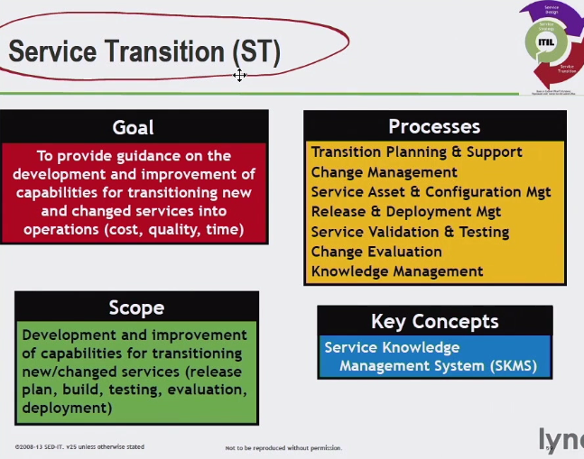

**Transition Planning and Support (TPS) – coordinate the service transition phases – resources required for that**

**Change management**

Approving and scheduling through service transition

**(SACM) Service Asset Configuration Management** – Manages Service Assets

**RADM Release and Deployment Management –** Build Test Deploy of ST

**SVT Service Validation and Testing–** Process within BTD – test new change services for utility and warranty

Utility is fit for purpose/warranty is fit for use

**Change Evaluation –** Verify that performance meets the requirements

**Knowledge Management -** ensuring reliable safe info. for the ST and future phases

**SKMS Service Knowledge Management System:**

Used to manage Knowledge & Information

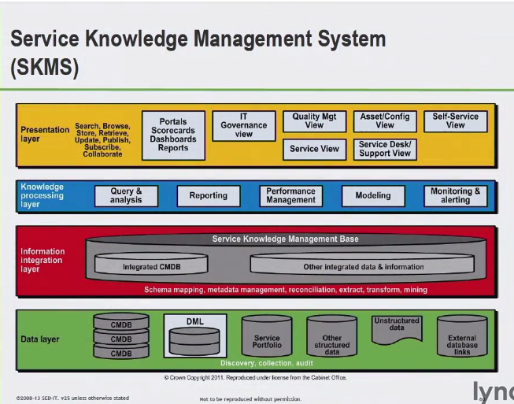

CMDB Config. Mng. Database

Collection tools and databases to store org. knowledge

* CSI register – collection/list of improvement initiatives
* Budget/models
* Proc: Policies

Mgt Syst.

* Project: Plans
* Diagnosis Scripts
* Cust./User Info.
* Configuration Management System (CMS)
  + Central view point of one or more CMB

CMDB – DB store info./attributes/relationships – for support of services

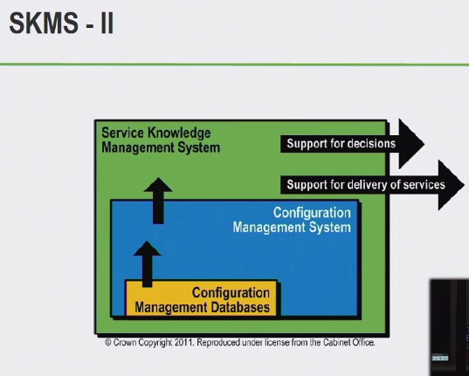

**VALUE TO THE BUSINESS OF SERVICE TRANSITION**:

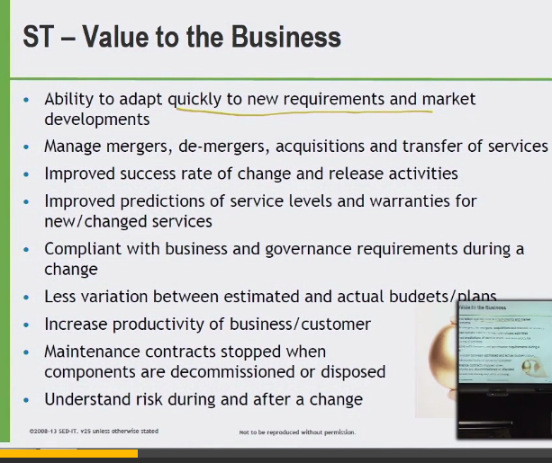

1. Process models – strategy and design changes needed

3. Approval Scheduling. Build test and deploy

**SERVICE OPERATION: Purpose, scope, processes, and key concepts**

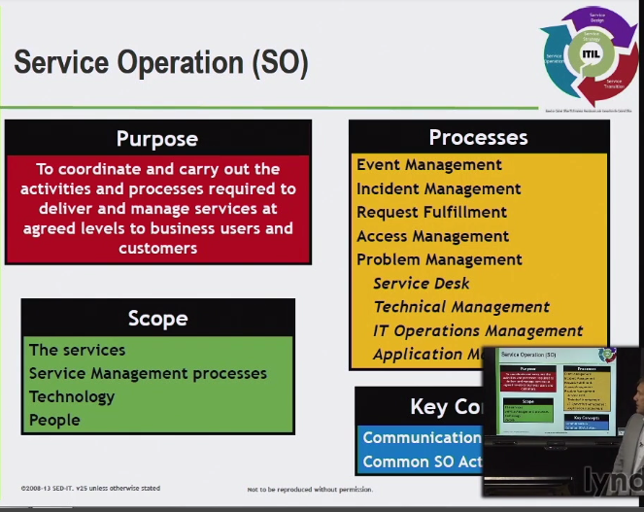

Now a live service – visible to customers

Managing technology and people

**Event Management**

* Monitoring changes in state
* Determine if action needs to be taken

**Incident Management**

* Restore normal services as possible
* Reduce neg. affect on customers

**Request Fulfillment**

* Incident or general request – service requests

**Access Management**

* Allowing/denying access security policy

**Problem Management**

* Root call analysis
* Reduce reoccurring incidents – reduce pain

**Service desk**

* **Central point of contact user and service provider**

**Technical Management**

* **Technical aspects and knowledge of the infrastructure**

**IT Operations Management**

* **Day to day operations**

**Application Management**

* **Life cycle of applications**
* **Knowledge track and manage**

**Key Concepts**

**Communicating with other things of the lifecycle**

* **Routing ops comm.**
* **Shifts**
* **Perf. Reporting**
* **Project reporting**

**Common SO activities**

* **Monitoring and control**
* **IT ops**
* **Network management**
* **Desktop support**

**CSI Continual Service Improvement: Goal, Process and Key Concepts**

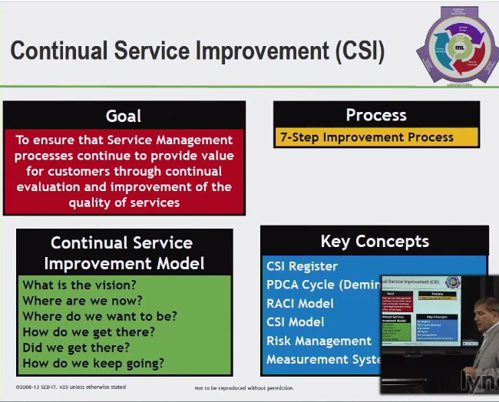

CSI touches every phase of the life cycle

PDCA Plan Do Check Act DEMING model

* Measures and monitors
* *Process compliance*
* Collecting and measuring parts of the process
* *Quality*
* How quality is defined – metrics key indicators
* *Performance*
* How well are we meeting standards Service Level
* *Business Value*

**Objectives**

1. REVIEW ANALYZEPRIORTIZE AND RECOMMEND IMPROVEMENTS VIA EACH LIFE CYCLE PHASE
2. REVIEW ANALYZE SERVICE LEVEL ACHIEVEMENT
3. IDENTIFY AND IMPLEMENT ACTIVITIES TO IMPROVE SERVICE QUALITY IMPROVE COST EFFICIENCY OF SERVICE DELIVERY, CUSTOMER SATISFACTION, QUALITY MEASUREMENT METHODS, CLEAR OBJECTIVES – WHY DO WE EVEN DO THIS IN THE FIRST PLACE?

SCOPE – TOTAL CONDITION OF IT MANAGEMENT

ALIGNMENT OF PORTFOLIO

MATURITY AND CAPABILITY OF ORGANIZATION PROCESSES

7**-STEP IMPROVEMENT PROCESS**

**CSI Register - Record of all improvement opportunities**

**PDCA Cycle (Deming)**

**RACI Model**

**CSI Model**

**Risk Management – risks and counter measures**

**Measurement Systems & Metrics**

**Service Measurement Systems and Metrics**

**SMART – specific measurable appropriate/achievable/accurate relevant/repeatable/realistic timely**

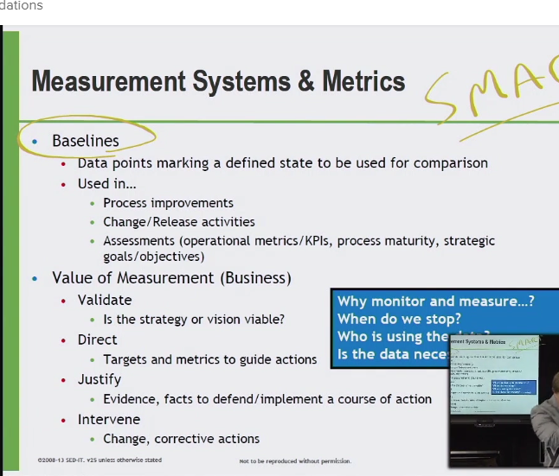

Baselines

* Mile marker to see how far we’ve come
* Reference point – better or worse?
* Compare in the future

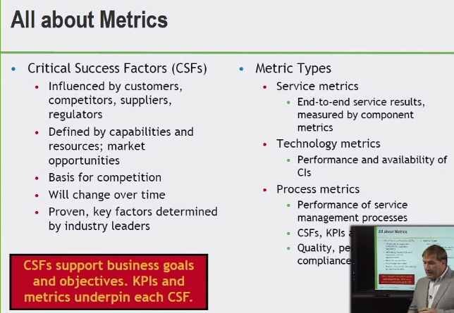

Critical Success Factors (CSFs)

* Generic Actions
* Qualitative
* Supported quantifiable key indicators
* Behavior we try to follow

Key performance indicator

* Specific metric

KPI key performance indicator

* Behavior measured over time

Metric

* Measures variable meets defined target

CI Configuration Item

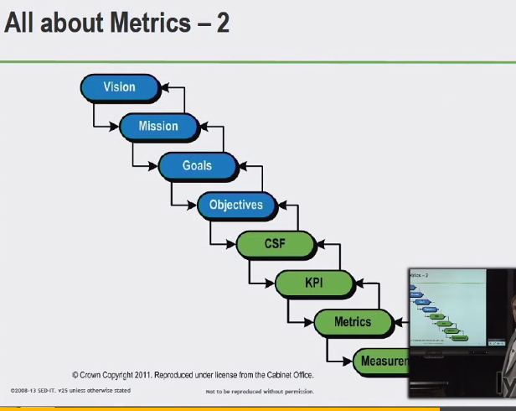

Collecting and measuring those measurements

**(CSI) The Continual Service Improvement Register**

* Keep track of multiple improvement efforts/initiatives planned or progress

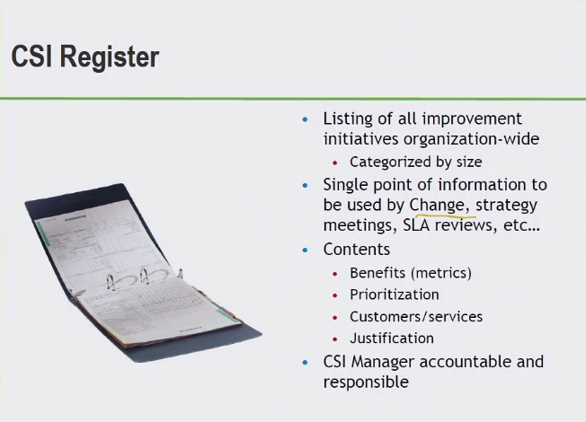

**Continual Service Improvement Model**

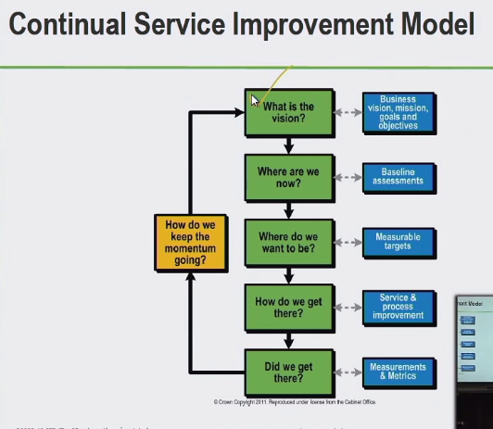

Soak or embed culturally in the organization

PCDA plan do check act DEMING Model

**The Plan-Do-Check-Act- (PCDA)**

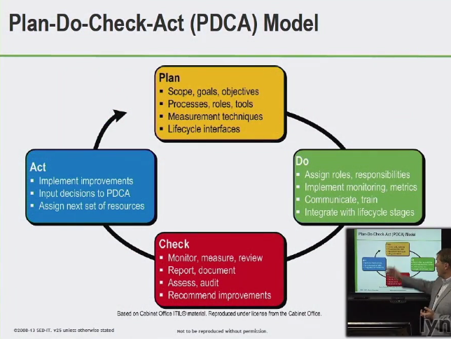

* Improve and moving up quality in the organization

**Value to the business of Continual Service Improvement**

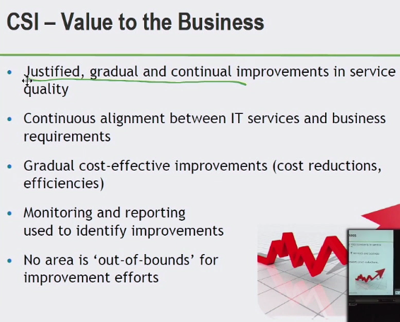

**INEGRATION OF THE FIVE CORE PHASES**

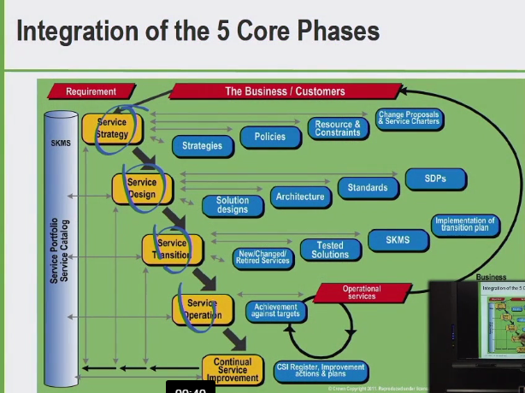

**SUMMARY: LIFE-CYCLE PHASES**

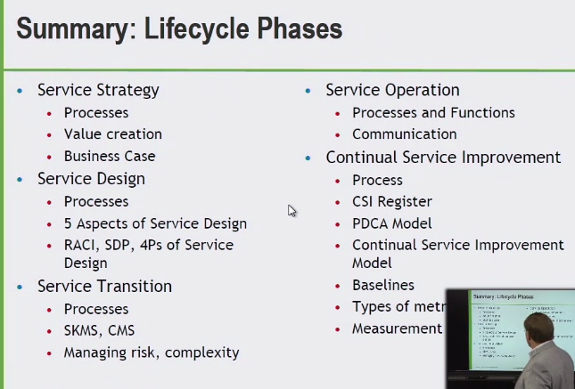

Service Strategy

* Providing the value for business services
* Looking at what the customers are expecting
* First step to improvement
* Value creation via services

Service Design

Service Transition

* New changes design phase into operation

Service Operations

Continual Service Improvement